Topic 1: Basic Linux Commands
1. pwd
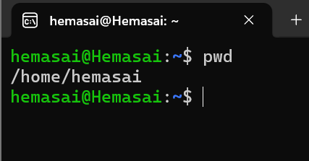
2. Clear
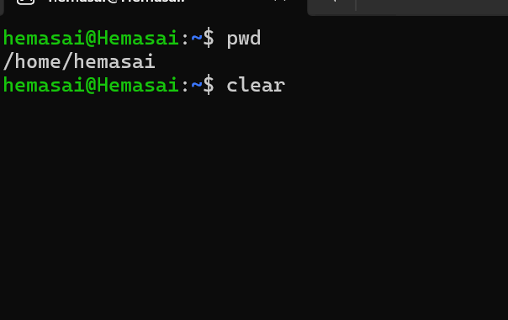
3. History
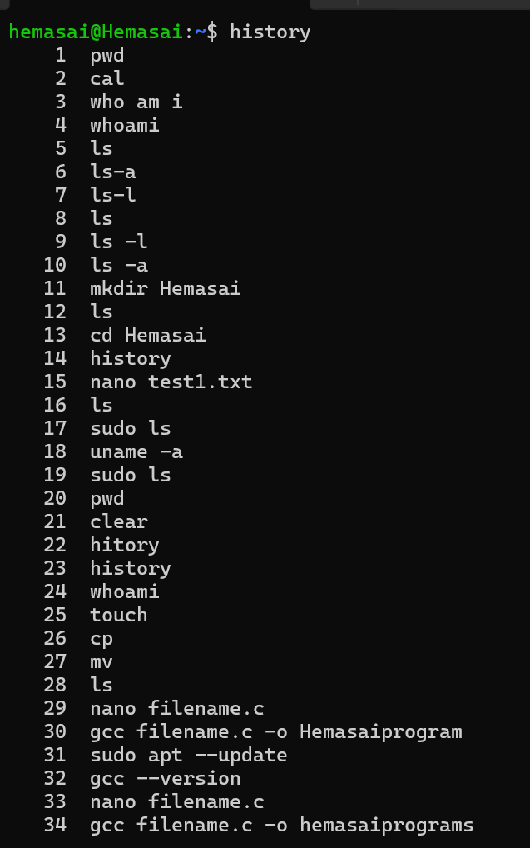 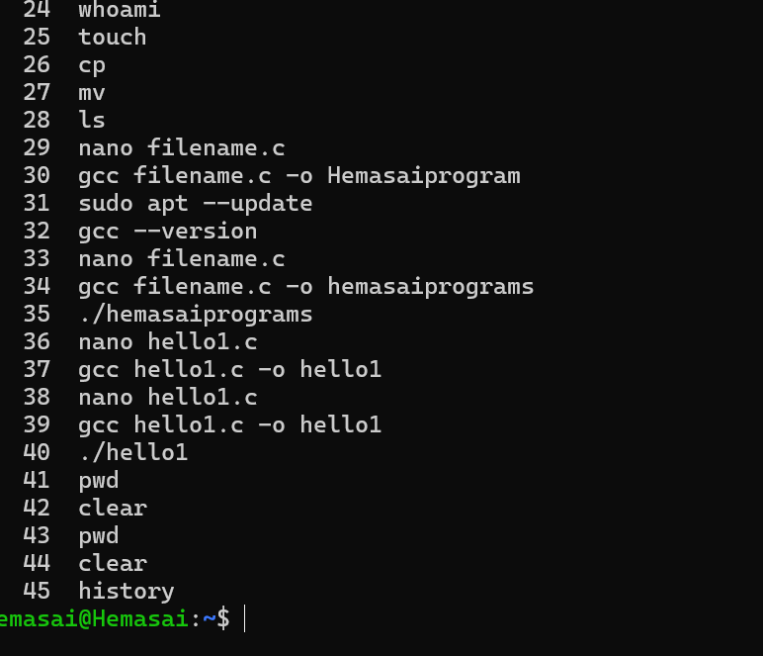
4. Whoami
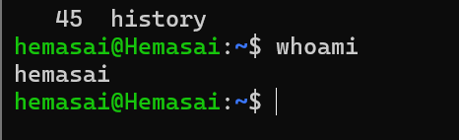
5. Date
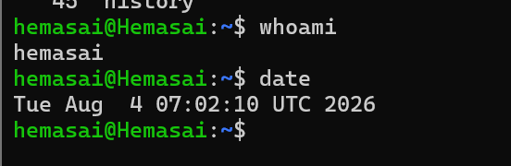
6. Cal
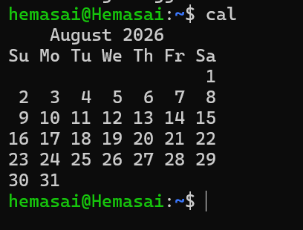
7. Hostname
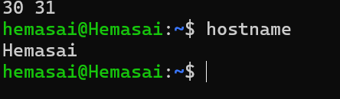
8. uname -a
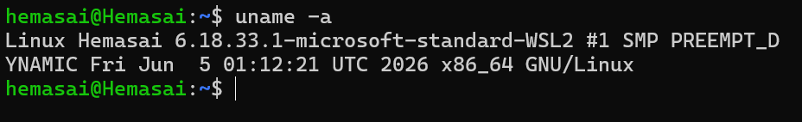
9. Exit
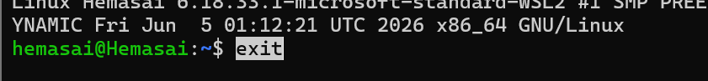
Topic 2: Directory Management
10. Ls
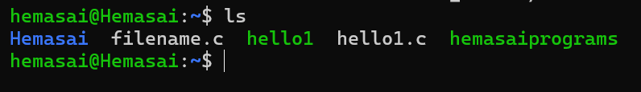
11. ls -l
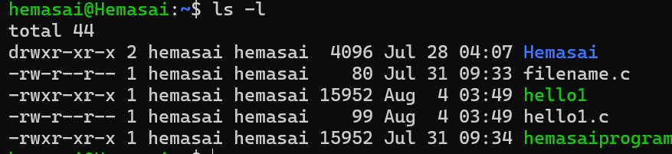
12. ls -a
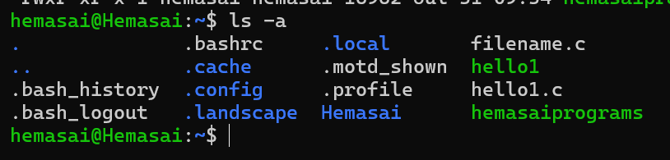
13. Cd


14. cd ..

15. Mkdir

16. Rmdir
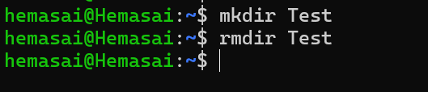
17. Find
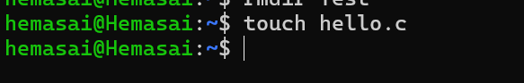
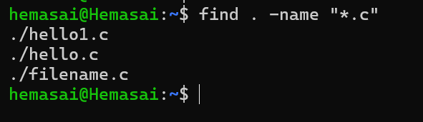
18. Locate
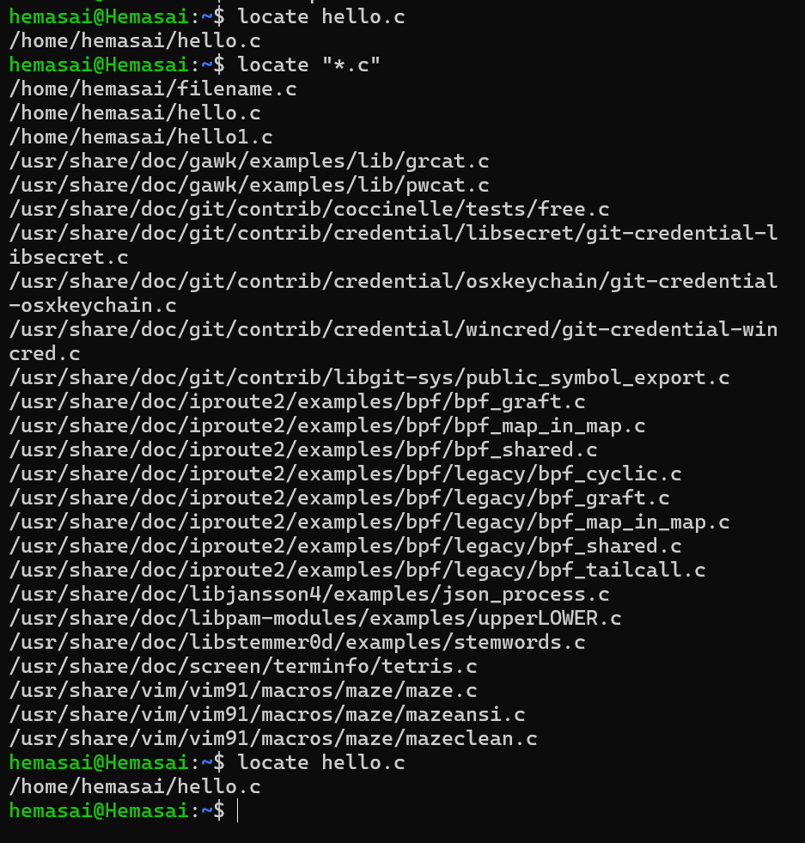
Topic 3: File Management
19. Touch
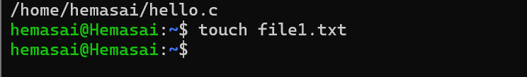
20. Cat
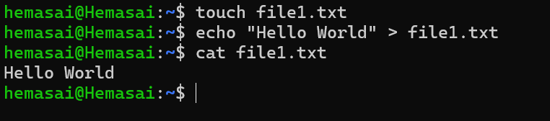
21. Cp
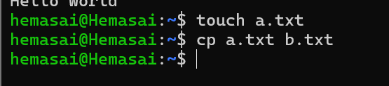
22. Mv
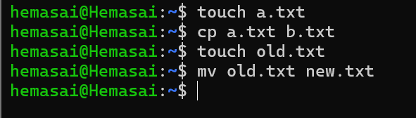
23. Rm

24. Head
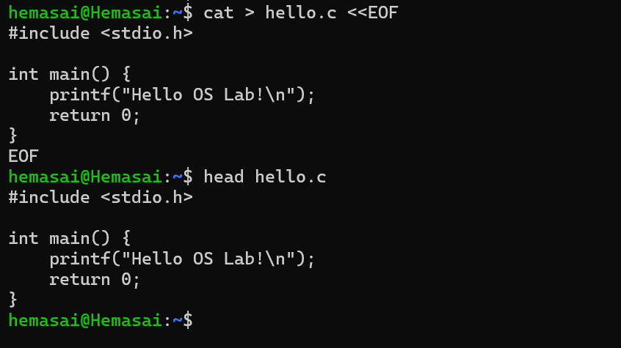
25. Tail
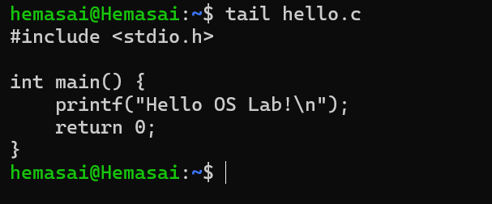
26. More
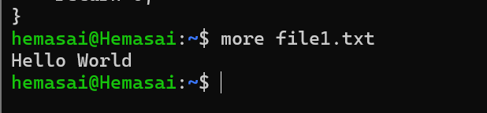
27. Less
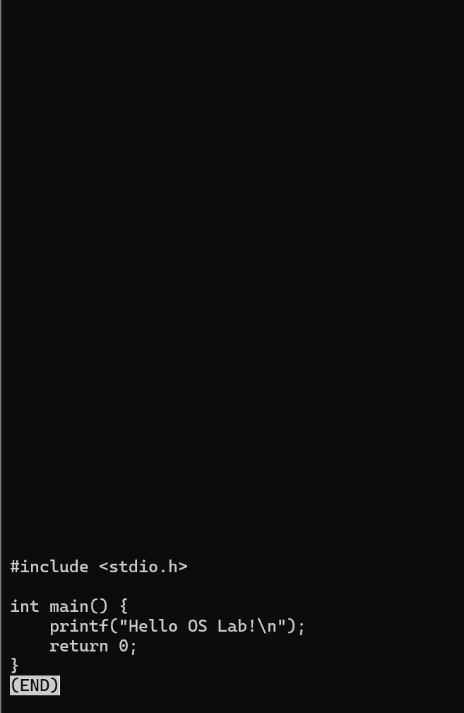
28. Wc
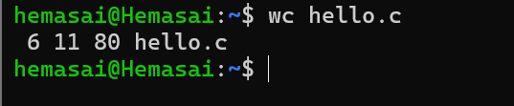
29. diff
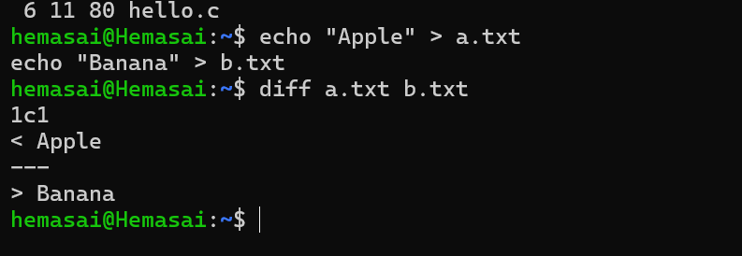
30. Sort
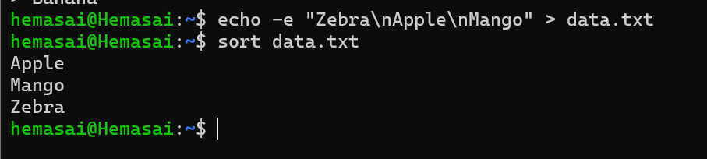
31. Uniq
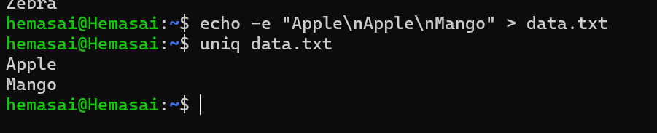
32. Grep
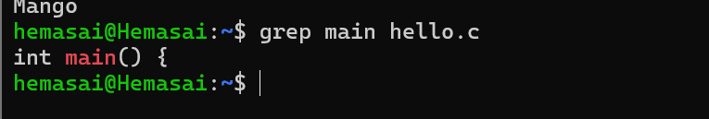
Topic 4: File Editing
33. Nano
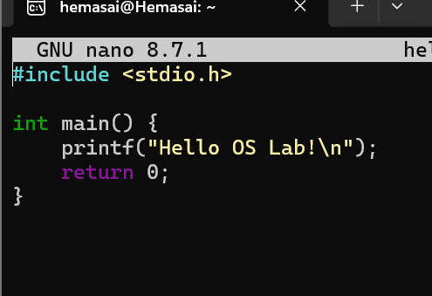
34. Vi
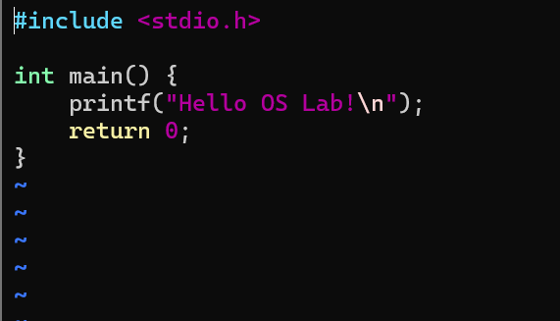
Topic 5: C Program Compilation and Execution
35. Gcc

36. ./program
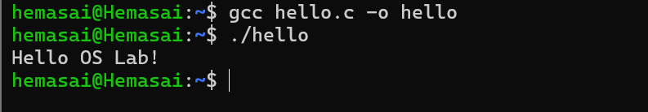
37. Which
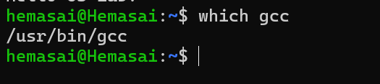
38. Whereis
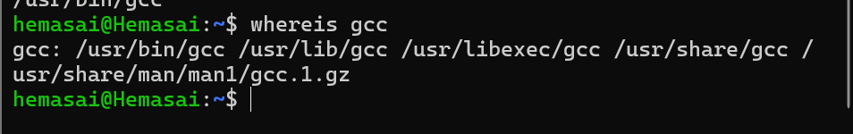
39. Man
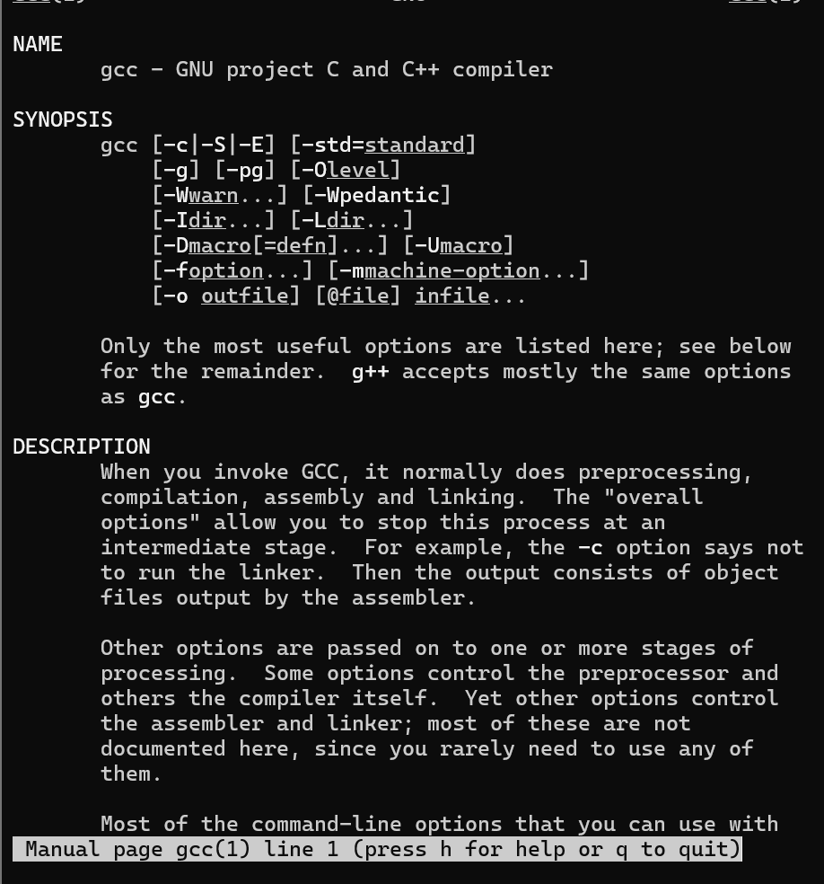
Topic 6: Process Management
40. Ps
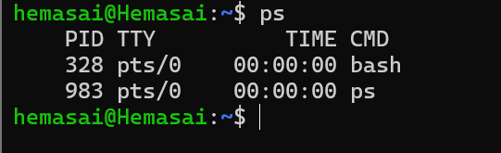
41. ps -ef
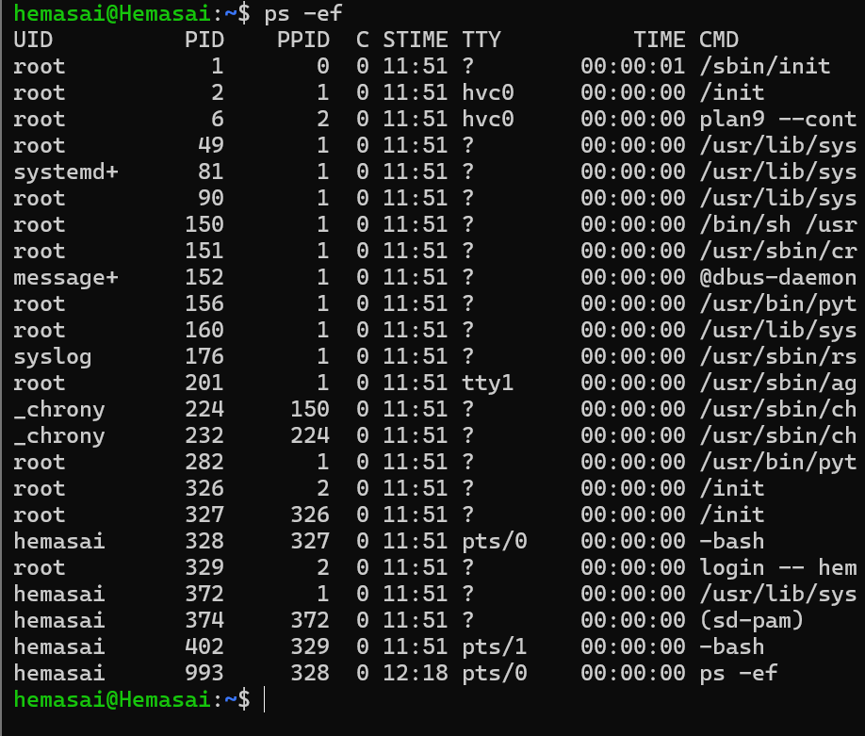
42. Top
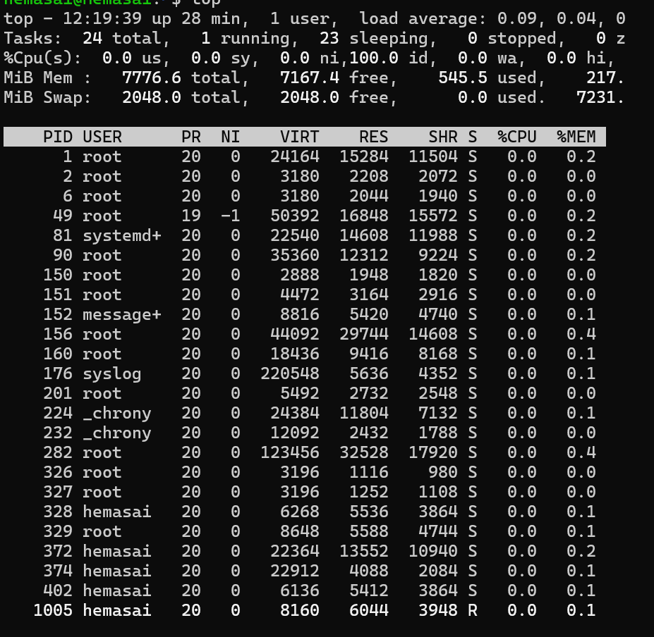
43. Kill
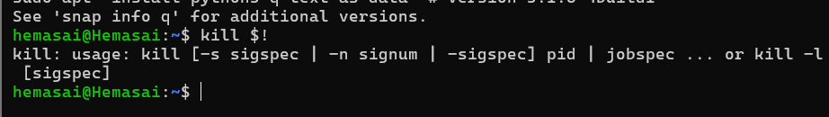
44. kill -9
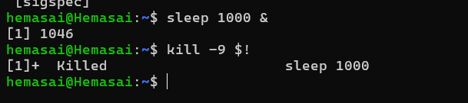
Topic 7: Job Control
45. Jobs
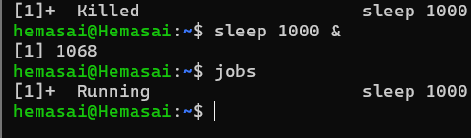
46 & 47. fg and bg
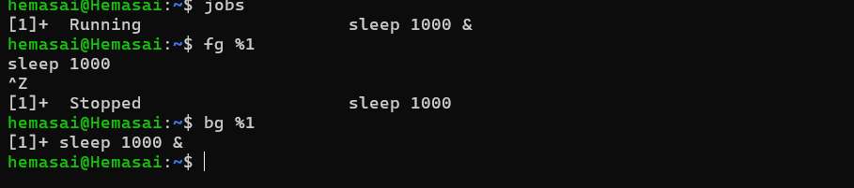
48. &
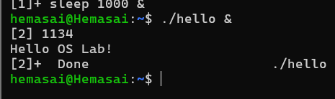
Topic 8: File Permissions and Links
49. chmod
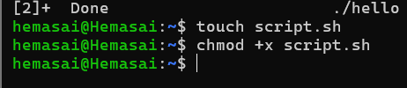
50. chmod 755

51. Ln
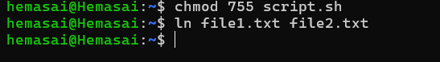
52. ln -s
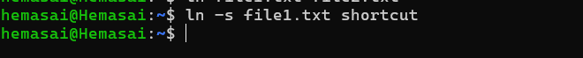
Topic 9: Disk and Memory Information
53. df -h
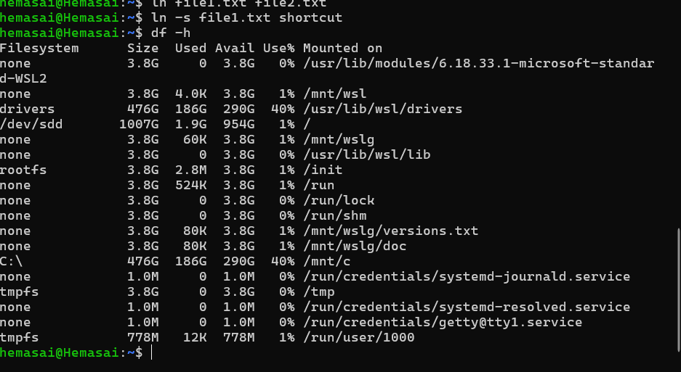
54. du -sh
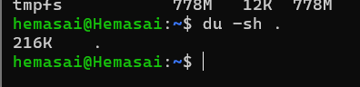
55. free -h
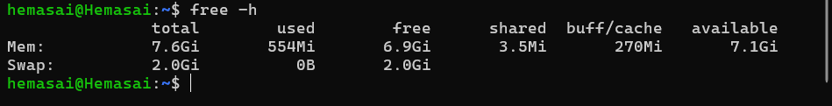
Topic 10: User and Environment Management
56. Id
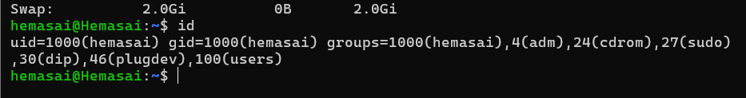
57. Env
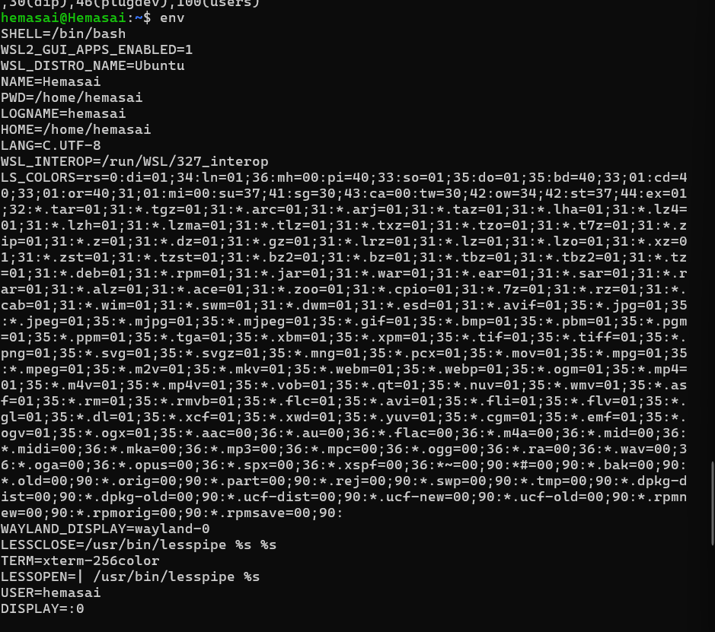
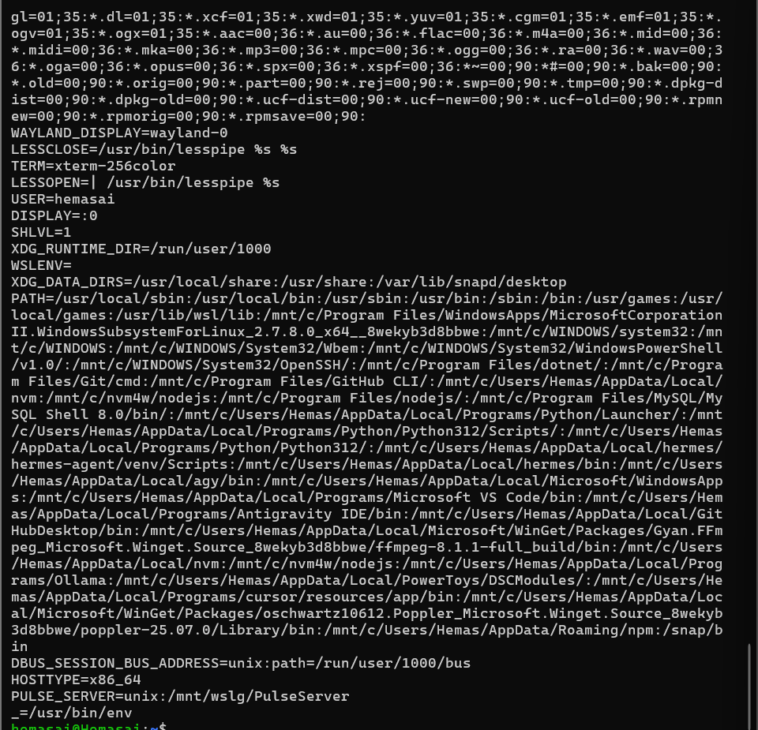
58. Export
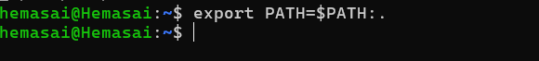
59. Alias
